Sprint backlog

# list of requirements for the sprint:

## Hardware Requirements:

* Laptop
* webcam
* speakers
* smart phone

## Software Requirements:

* QR code reader
* audio recording software
* speaking software

## User Interface Requirements:

* a camera interface

## Performance requirements:

* quick response
* clear instructions
* user friendly

## Safety Requirements:

* Safe route

## Ethical Requirements:

* Privacy protection
* Permission request

## Form a task list and estimate the task length

|  |  |  |  |
| --- | --- | --- | --- |
| **Task** | **Person assigned to it** | **Period** | **Priority** |
| Design UML diagram/model | Bader | 1 hours | B |
| Get the example code working | Paulius | 1 hours | A |
| Create a GitHub page | Marcin | 15 mins | A |
| Record the audio directions | Bader/Paulius | 1 hours | A |
| working on the code prototype | Paulius/ken | 1 weeks = 168 hours | A |
| Generate QR codes | Paulius | 1 weeks = 168 hours | A |
| Generate audio directions | Bader/ken | 1 weeks = 168 hours | A |
| Add a different room | Paulius | 1 day = 24 hours | B |
| Record the audio directions in different languages | Bader\Paulius | 1 hours | C |
| Perform dry run of demo | Bader/Paulius | 30 min | A |
| Commit project to GitHub | Bader | 10 min | B |

# Burndown chart:

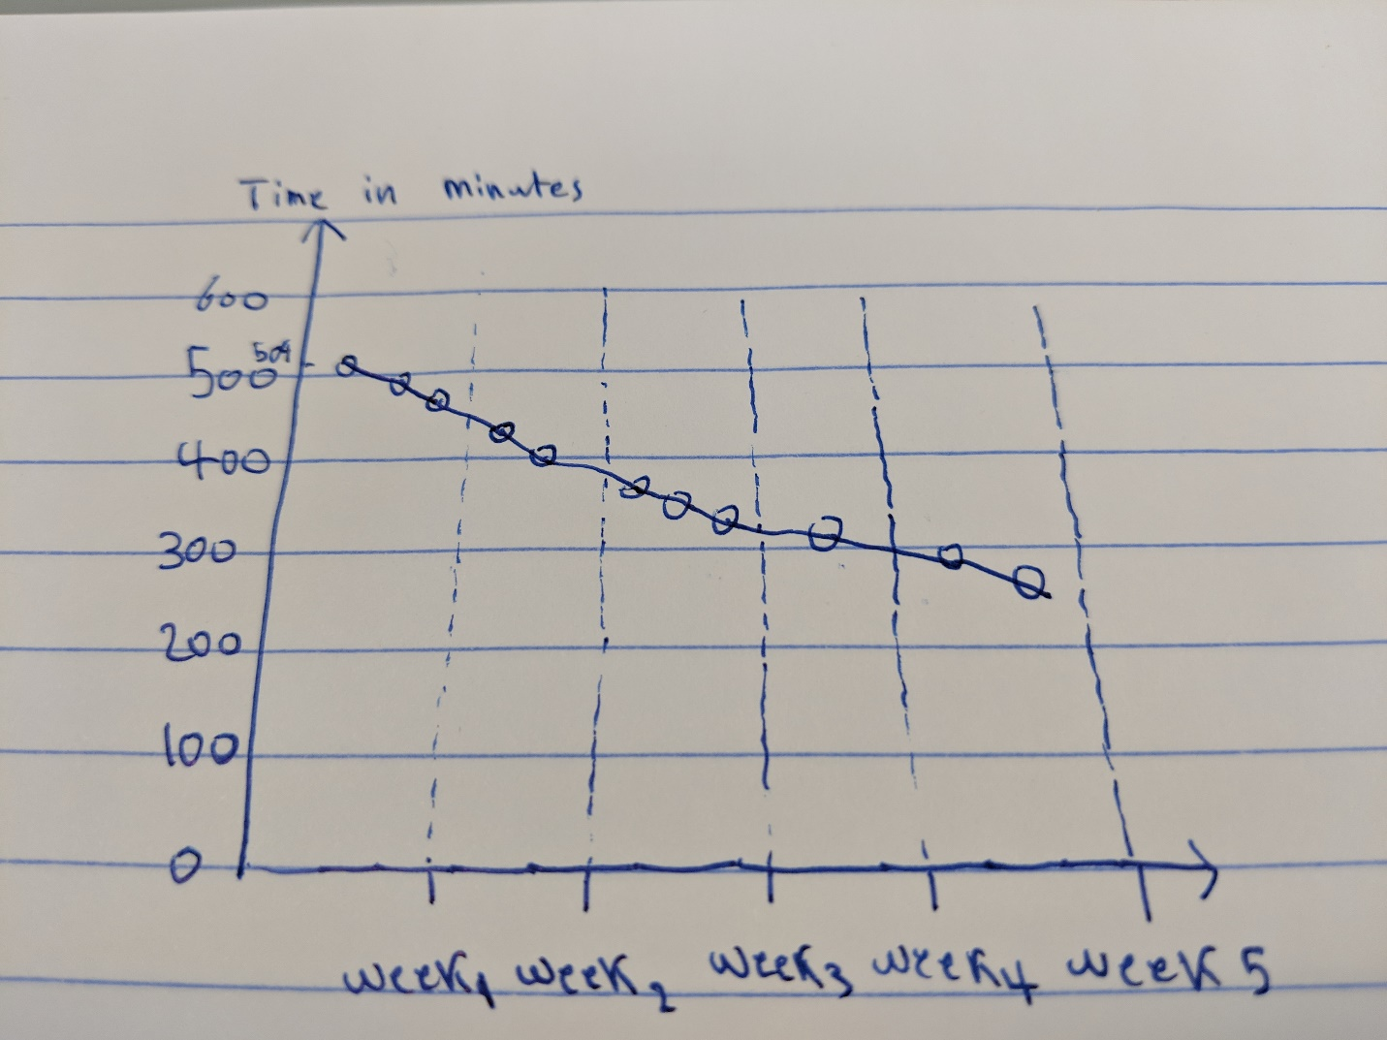

# UML diagram of the project:

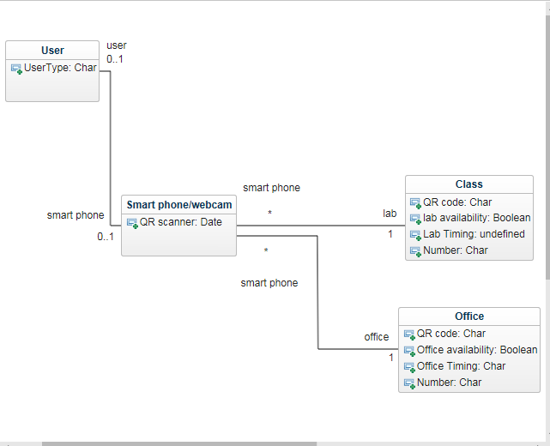

# Link to GitHub:

<https://github.com/student174918/softwareEng>